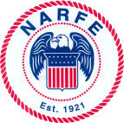
TRI-CITIES CHAPTER 1192
NARFE NEWS
National Active and Retired Federal Employees Association
Advocates for Active and Former Federal Employees
www.NARFE1192.org

November - December, Volume 2010, Issue 6

2010 Chapter 1192 Officers & Board Members

President, Gary Hagedorn 509-547-3015
1st Vice President, Don Binder 509 585-1393
2nd Vice President, Carl Gallion 509-967-9161
Treasurer, Nancy Crosby 509-735-3288
Secretary, Mary Alice Binder 509-585-1393
Legislative, Don & Mary Alice Binder 509-585-1393
NARFE-PAC, Don Binder 509-585-1393
Service Officers, Mary Goldie, 509-582-8757
Nancy Schreckhise 509-585-7558
Alzheimer’s, Bill Darke 509-375-7757
Public Relations, Gary Hagedorn 509-547-3015
Sunshine, Marci Lingle 509-627-6628
Parliamentarian, Mable Rutt 509-943-1812
Hospitality, Carl Gallion 509-967-9161
Membership/Newsletter,
Johanna Caylor 509-308-6664
Webmaster, Larry Williams 509-783-8554
Deacon, Al Rizzo 509-375-0446

CHAPTER MEETINGS/EVENTS
Meetings: 1st Wednesdays, except July/August
11:30 a.m., Kennewick Red Lion, Clearwater “C”
Lunch: $13; reservations requested
Executive Board meets after Chapter meetings

November 3 – Chapter Meeting: White Elephant
Auction for Alzheimer’s Research Fund
(Bring item/items for the auction!)
Menu: Mustard Crusted Pork Loin

December 1 – Chapter Meeting: Officers Installed
and, Tri-City Tappers performance
Menu: Tillamook Cheddar Chive Chicken

OCTOBER TREASURER’S REPORT*
Balance forward, August 31 $ 6957.50
September Income $ 510.04
September Expenditures $ 372.13
Dedicated funds, 18-mo. budget $ 1208.00
Balance on hand, September 30 $ 5887.41
(*Full reports are on the Chapter web site.)

SERVICE CENTER
Open Tuesdays, 9:30 – 11:30 a.m.
Federal Bldg., Richland, Room 137
Phone: 509-373-9536

Needed – Volunteers to serve in two Chapter positions, Service Center Coordinator and
Call-Tree Coordinator. Our current volunteers,
Mary Goldie and Nancy Schreckhise, who have covered both functions since 2006, are resigning
due to family priorities. If you want to know more about either position, please call Mary, 582-8757. Please consider one of the coordinator positions!
From Mary and Nancy …
“It has been our pleasure serving you. We are
certain the persons taking over the positions will do
a fantastic job. We will continue to volunteer one day
a month at the Service Center and hope you visit!
Our special thanks to all the Service Center
volunteers and all the callers who helped with calls
for the monthly meeting notifications. We could not have done our coordinator jobs without all of you!”

Good to Know
OPM: 888-767-6738, “Retirement Info Line”
OPM: www.opm.gov/retire/
Resource Guide: Be Prepared for Life’s Events (available at: www.narfe.org)
Washington Federation: www.narfewa.net

HOSPITALITY
Vegetarian plates – available for the monthly meetings, if ordered ahead. Just let 4151 your reservation caller know.

Reminder – the Chapter must pay for the number of reservations given to the hotel, even for “no shows.” Cancellations must be made not later than noon Monday prior to the Chapter meeting. To cancel a reservation, call Pam Griffin, 492-4304.

Chapter President – Gary Hagedorn
It was great to see such good attendance at
Chapter 1192’s October monthly meeting! We thank Mr. Loren Eddy, a local attorney who specializes in estate planning, for such an interesting and timely presentation. Personally,
I learned a few things I need to review.
Now, we are in the election season. I would like to remind everyone to vote. The issues of the day – economy, federal and state spending, national defense, etc. – are vital to all of us and need our thoughtful consideration.

Staying with elections, the following members have been nominated for 2011 Chapter 1192 officer positions:
- Don Binder, president
- Carl Gallion, 1st vice president
- Mary Binder, secretary
- Nancy Crosby, treasurer
Elections – at the November Chapter meeting; installation of officers, at the December meeting.

But, we still need volunteers to serve as:
- 2nd vice president;
- Service Center coordinator; and,
- Call-tree coordinator
Please consider volunteering to serve in one of these positions. Serving as 2nd vice president allows for gradually learning more about NARFE at the chapter, state and federal levels. The coordinator positions are, in fact, as the titles
say, “coordinators.” Both positions have teams
of great volunteers to support them. So, if you are interested in serving in one of these positions, please contact me at either 509-547-3015 or
509-546-2117. As I wrote in the last newsletter, this would be an excellent time to step forward
if you are interested in NARFE leadership or to just serve.

Switching topics, as we get closer to winter, remember the preparations you need to make for your safety. Examples: winterize your car, including having proper traction tires; prepare for potentially slippery surfaces; and, consider 7021 water-freezing issues around your home and equipment.
Looking ahead – see our Alzheimer’s chairman
Bill Darke’s reminder about our annual white elephant auction at the Chapter’s November meeting. As he wrote, proceeds go to NARFE’s Alzheimer’s Research Fund. Then in December, I’m pleased to announced that the Tri-City Tappers will provide a holiday program for us at our Chapter meeting. This is “…an over-50 tap-dancing group established in 1994 and that has become a favorite all over town!”

So, great programs and great opportunities to bring a “fed” to one or both of our fall meetings! Whether current or retired, I urge everyone to bring a “fed friend” to a meeting. Help us reach one of our Chapter’s 2011 goals – increase membership! Yes, strength is in numbers.

Finally, the Chapter Board will have a combined monthly board/2011 planning meeting at a working lunch, Tri-City Country Club, Kennewick, Wednesday, November 10, starting at 10:30 a.m. Feel free to join us and enter into this process.
Just call Mary Binder, Chapter secretary, at
509-585-1393, for seating and lunch purposes.

Have a good month, and I hope to see you and a “fed friend” at our upcoming meetings.
Open Season
Federal Employees Health Benefits
November 8 through December 13

“The FEHB Program has important features, including a wide choice of health plans and competitive benefit packages as well as no pre-existing condition limitations or waiting periods. Now, for 2011, we have eliminated enrollee cost sharing for preventive care services, added incentives for tobacco cessation, and, in accordance with the Affordable Care Act, added coverage for dependents up to age 26. Even with these new benefits, premiums will rise less this year than they did last year.”
John Berry
Director, U.S. Office of Personnel Management

Note: 2011 FEHBP premium rates – health care, dental, vision – and the October 1 NARFE release about the rate increases are at: www.opm.gov.

2nd VP Update – Carl Gallion
After months of waiting, Carl Gallion had his hip “re-surgery” October 7 and is now diligently working through his rehab process. All the best and see you soon, Carl!
Alzheimer’s Research Fund – William Darke
November is Alzheimer’s Month and we will have our annual white elephant auction at our Chapter meeting. This is the perfect opportunity to do some holiday shopping, get some unique gifts at reasonable prices and also maybe donate some items you no longer need or want! All auction proceeds will be donated to NARFE’s Alzheimer’s Research Fund. Over the years, NARFE members have donated more than $9M for this research, and NARFE is now working toward a revised goal of $10M! For anyone not able to make the meeting, your NARFE magazine has an Alzheimer’s donation form you can use. Please contribute what you can; it’s all for a good cause!

Sunshine News – Marci Lingle
Cards have recently been sent to:
- The family of Carl Qualheim, a Chapter member, upon his passing
- Member Don Binder upon the passing of his mother, Rita, also a Chapter member
- Member Lyle Bingham who is in Kadlec Rehab
- Russ Bechtol, whose wife, Susan, is a DOE employee/member, after his recent surgery
- Member Roger St. John and his wife congratulating them on 68 years of marriage
- Connie Castleberry, a DOE employee/member on the passing of her sister
- Julie Goeckner, a DOE employee/member, whose mother was in an accident, and
- Life member Beryl Crouter, who broke her leg

Please continue to let me know about members affected by a significant event such as an illness, loss, or an extra-special occasion. Contact me at: tclingles@clearwire.net or
503-627-6628.

Legislative – Don and Mary Binder
Is your head spinning this election season? Yes, there has been a plethora of information! Yes, 3100 it can be perplexing; and yes, at least for most of us, it requires listening, reading and studying before voting. So, if you haven’t already voted, we encourage you to study the issues and candidates, and then ensure you vote on or before Election Day 2010, Tuesday, November 2. Does your vote count? To answer that, just reflect on our state’s gubernatorial race a few years ago!

Next, a “legislative” word from …
District V Vice President – Steve Anderson
NARFE has announced its “legislative program” for
the upcoming 112th Congress, January 1, 2011 – December 31, 2013. The platform includes:
- Increased emphasis – federal employee pay
parity;
- Allowing members of Congress and their staff
to remain in the FEHB Program;
- Monitoring/reporting on the “debt commission;”
- Supporting a USPS refund from the Civil Service Retirement and Disability fund provided there
is no resulting reduction in federal annuities;
- Asking Federations to submit proposed amendments to NARFE’s “legislative program” between conventions; and,
- Actively pursuing OPM support to apply for a subsidy that would lower FEHB premiums.

Contacting our Federal Legislators

The Honorable Richard (Doc) Hastings,
U.S. House of Representatives
Phone: 202-225-5816; Fax: 202-225-3251
http://hastings.house.gov/ContactForm.aspx
2715 Saint Andrews Loop, Suite D
Pasco, WA 99301
Phone: 509-543-9396; Fax: 509-546-1972

The Honorable Patty Murray, U.S. Senate
Phone: 202-224-2621; Fax: 202-224-0514
http://murray.senate.gov/email/index.cfm
402 East Yakima Avenue, Suite 390
Yakima, WA 98901
Phone: 509-453-7462; Fax: 509-453-7731

The Honorable Maria Cantwell, U.S. Senate
Phone: 202-224-3411; Fax: 202-228-0514
http://cantwell.senate.gov/contact/index.dfm
825 Jadwin Avenue, Suites 204/204A
Richland, WA 99352
Phone: 509-946-8106; fax: 509-946-6937

NARFE-PAC – Don Binder
It has been a busy PAC season! As of September 30, 75 chapter members had contributed $1,961 during the current PAC cycle starting January 1, 2009. For a recap of PAC contributions, including funds donated to Washington’s congressional candidates, go to www.narfewa.net; click on “NARFE PAC.” Don’t see your candidate listed? How does the process work? For a review, go
to NARFE-PAC Frequently Asked Questions at www.narfe.org. Log in as a member, go to
Special Programs and then NARFE-PAC.

Questions? Contact me at: 509-585-1393, or don_binder@msn.com.

National Active and Retired Federal Employees Non-Profit Organization
Johanna Caylor U.S. Postage
514 Stagecoach Ct PAID
Richland, WA 99354 Permit No. 173
Email: caylorx2@aol.com Richland, WA

Return Service Requested

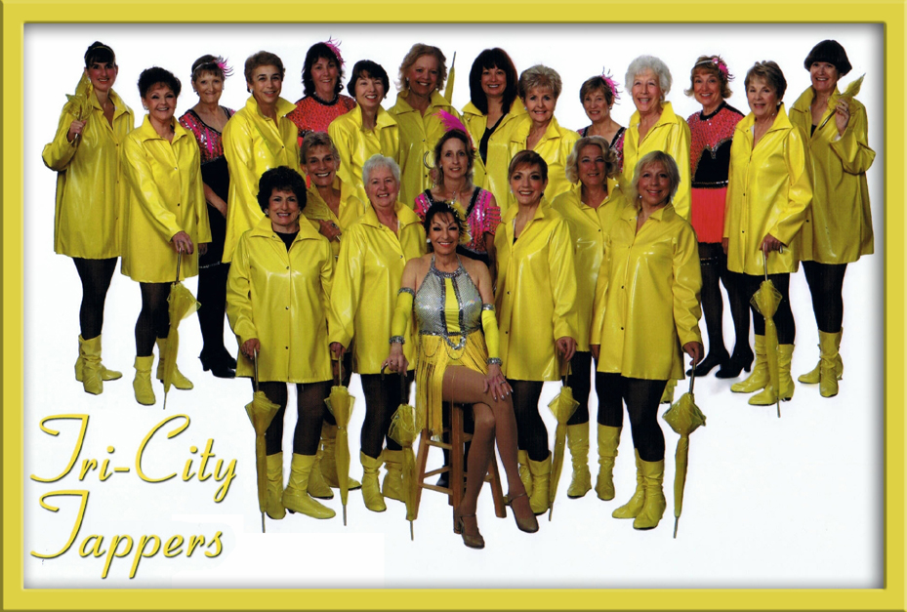

Tri-City Tappers, December 1
NARFE Chapter 1192 Meeting!

Membership – Johanna Caylor
Welcome: See “Transfer In” below
Reinstated: Dorothy Smith, Vicki Wiley
Dues Withholding: Michael Barrett, Ami Sidpara Transfer In: Barbara Fedoriga (HI), Carole McGraw (MT)
Renewals: Lost your renewal slip and need help? Call me and I will walk you through the process.
Remember: The 2010-2011 WSFC Federation Membership Campaign with $10 rebates for: 1-Dues withholding; 2-Gift memberships; and, 3-Spouse sign up.
Reminder: If you change your mailing or e-mail addresses, or phone number, please contact me. This is very important so we can continue to provide you Chapter information. Snowbirds – if you have a winter mailing address you want us to use, please let me know.
Help: NARFE not only needs new members – we need to retain the members we have. Help our Chapter and NARFE grow and sustain strength!
Call me: If you have questions, please call me. My numbers are: 509-375-0739 or 308-6664.

Dues Increase: NARFE membership dues are increasing in 2011 to $40/year, effective in March, on the member’s membership anniversary date. Chapter dues remain $10/year. For retired members, using dues withholding means a 15% reduction in NARFE dues, plus – send no money with the application and no more renewal notices!
Another option – life membership, which can be paid in installments.
Hidden numbers: There are 3 in this issue – last 4 digits of a member’s number. Contact me if you find yours; win $5! September/October newsletter hidden numbers belonged to: Pat Baker; Dorothy Hailey; and, Don Segna. No winners!

Upcoming Dates to Remember:
Election Day, November 2
Daylight Saving Time Ends, November 7
Veterans Day, November 11
Thanksgiving, November 25
Hanukkah Begins, Sundown, December 1
Christmas, December 25


