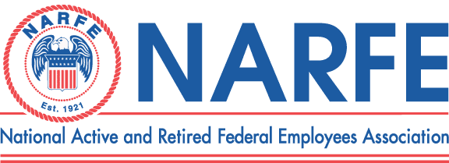
 | February 2, 2011 Treasurer's Monthly Report Chapter1192
Period Ending: January 31, 2011
 | RECEIPTS |  |  | BALANCE ON HAND - |  |  |  | Last Report | $7,753.51
1 | National Dues RecFee2 DW109.56/11/40/12/136.34/13/9.67/14/10 (DEC Dues) |  |  |  |  |  | 302.57
2 | WSFC Service office
3 | WSFC Membership/MAP/Rebates
4 | Newsletter Donations/Awards |  |  |  |  |  | 10.00
5 | PR/Ways &Means/Raffle |  |  |  |  |  | 15.00
6 | WSFC Per Capita Rebate
7 | Paid Lunches |  |  |  |  |  | 304.00
 |  | TOTAL RECEIPTS |  |  |  |  | $631.57
 |  |  | TOTAL TO BE ACCOUNTED FOR |  |  |  |  |  | $8,385.08
 | DISBURSEMENTS
1 | WSFC Assessment Per capita
2 | Chapter Liability Insurance
3 | WSFC Membership MAP
4 | Membership Expenses
5 | Printing/Distinquished Members
6 | Sunshine Committee
7 | Presidents Discretionary Fund
8 | Service Center
9 | PR TCVCB/Advertising/Expos
10 | Website Domain
11 | Newsletter 6 Issues -Permit |  |  |  |  |  | 61.67 | 1/3 Bulk Mail Permit
12 | Secretary Supplies
13 | Treasurer Supplies/MISC/Badges
14 | Conventions/Workshops
15 | Monthly MeetingCosts /Entertainment
16 | Comped and Unpaid Lunches |  |  |  |  |  | 13 | 1 speaker
17 | Paid Lunches - Red Lion |  |  |  |  |  | 294.85
 |  | TOTAL DISBURSEMENTS |  |  |  |  | $369.52
 |  |  |  |  |  |  | SUB-TOTAL |  | $8,015.56
 |  |  | TOTAL ACCOUNTED FOR |  |  |  |  |  | $8,015.56
OBLIGATIONS
1 | Newsletter Expenses |  |  |  |  |  | 638.33
2 | WSFC Per Capita 338X1.40 |  |  |  |  |  | 473.20
3 | MultiYear Dues 2012 ($366)2013 ($9.67)2014 ($10) |  |  |  |  |  | 752.00
4 | Conventions/Workshops |  |  |  |  |  | 1,900.00
 |  | TOTAL OBLIGATIONS |  |  |  |  | $3,763.53
 |  |  | BALANCE ON HAND FOR USE |  |  |  |  |  | $4,252.03
Treasurer Signature__s/ Nancy Crosby___ |  |  |  |  |  |  | Date | January 31, 2011

