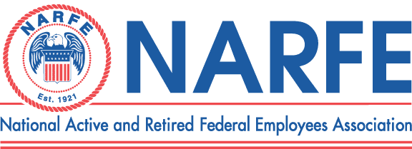

 |  |  |  |  | Treasurer's Monthly Report
 |  |  |  | Chapter Number 1192 |  |  |  | Location: | TriCities WA
Period Ending: |  | April 30, |  | 2011
 | RECEIPTS |  |  |  | BALANCE ON HAND - |  |  | Last Report | $7,463.27
1 | NATL Dues Mar 2011$100 2012 $20 DW $79.68 |  |  |  |  |  | 199.68
2 | WSFC Service office |  |  |  |  |  | 74.00
3 | WSFC Membership MAP
4 | Newsletter Donations/Awards |  |  |  |  |  | 12.00
5 | PR/Ways &Means/Raffle |  |  |  |  |  | 16.00
6 | WSFC Per Capita Rebate
7 | Paid Lunches |  |  |  |  |  | 307.00
8 | Recruiting Fee |  |  |  |  |  | 18.00 | 2 Natl 16 Binder
9 | 0
10 | 0
 |  |  | TOTAL RECEIPTS |  |  |  | $626.68
 |  |  |  |  | TOTAL TO BE ACOUNTED FOR |  |  |  | $8,089.95
 | DISBURSEMENTS
1 | WSFC Assessment Per capita
2 | Chapter Liability Insurance |  |  |  |  | 75.00
3 | WSFC Membership MAP
4 | Membership Expenses
5 | Printing/Distinquished Members
6 | Sunshine Committee |  |  |  |  | 8.80 |  | Stamps
7 | Presidents Discretionary Fund
8 | Service Center |  |  |  |  | 74.00
9 | PR TCVCB/Advertising/Expos
10 | Website Domain
11 | Newsletter 6 Issues -Permit |  |  |  |  | 132.47
12 | Secretary Supplies
13 | Treasurer Supplies/MISC/Badges |  |  |  |  | 17.60 |  | Stamps
14 | Conventions/workshops District Workshop 8@$14 |  |  |  |  | 112.00
15 | WSFC State Convention |  |  |  |  | 60.00 |  | Ad for book
16 | Comped and Unpaid Lunches |  |  |  |  | 52.00 |  | 2 comps 2 speakers
17 | Lunches Red Lion 27 |  |  |  |  | 325.83
 |  |  | TOTAL DISBURSEMENTS |  |  | $857.70
 |  |  |  |  |  | SUB-TOTAL |  |  | $7,232.25
 |  |  |  |  | TOTAL ACCOUNTED FOR |  |  |  | $7,232.25
OBLIGATIONS
1 | Newsletter Expenses |  |  |  |  |  | 491.00
2 | WSFC Dues |  |  |  |  |  | 238.00
3 | Multiyear dues 2012 ($482)2013 ($59.67)2014 ($20) |  |  |  |  |  | 562.00
4 | WSFC State Convention |  |  |  |  |  | 1,200.00
 |  |  | TOTAL OBLIGATIONS |  |  |  | $2,491.00
 |  |  |  |  | BALANCE ON HAND FOR USE |  |  |  | $4,741.25
Treasurer Signature______Nancy Crosby______________________________ |  |  |  |  |  |  | Date | April 30, 2011

