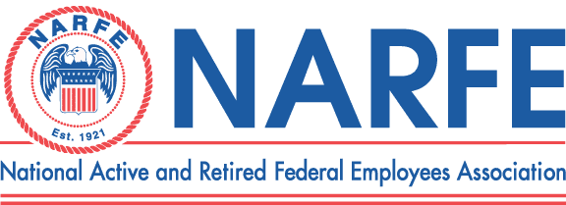

 |  |  |  | Treasurer's Monthly Report
 |  |  | Chapter Number |  | 1192 | Location: | TriCities WA
Period Ending: |  | June 30, | 2011
 | RECEIPTS |  |  | BALANCE ON HAND - |  | Last Report | $7,192.04
1 | National Dues Income |  |  |  | 293.16
2 | WSFC Service office
3 | WSFC Membership/MAP/Rebates
4 | Newsletter Donations/Awards |  |  |  | 30.00
5 | PR/Ways &Means/Raffle |  |  |  | 14.00
6 | WSFC Per Capita Rebate
7 | Paid Lunches |  |  |  | 305.00
8 | 0
9 | 0
10 | 0
 |  | TOTAL RECEIPTS |  |  | $642.16
 |  |  |  | TOTAL TO BE ACOUNTED FOR |  |  | $7,834.20
 | DISBURSEMENTS
1 | WSFC Assessment Per capita
2 | Chapter Liability Insurance
3 | WSFC Membership MAP
4 | Membership Expenses
5 | Printing/Distinquished Members
6 | Sunshine Committee
7 | Presidents Discretionary Fund
8 | Service Center
9 | PR TCVCB/Advertising/Expos |  |  |  | 13.92 | Candy for Expo
10 | Website Domain
11 | Newsletter 6 Issues -Permit
12 | Secretary Supplies
13 | Treasurer Supplies/MISC/Badges
14 | Conventions/Workshops
15 | WSFC State Convention |  |  |  | 825.00 | Reimb conv registrations/basket
16 | Comped unpaid lunches |  |  |  | 0.00
17 | Lunches Red Lion 23 |  |  |  | 321.85
 |  | TOTAL DISBURSEMENTS |  |  | $1,160.77
 |  |  |  |  | SUB-TOTAL |  | $6,673.43
 |  |  |  | TOTAL ACCOUNTED FOR |  |  | $6,673.43
OBLIGATIONS
1 | Newsletter Expenses |  |  |  | 391.00
2 | WSFC Dues |  |  |  | 238.00
3 | National Dues 2012/2013/2014 |  |  |  | 722.00
4 | WSFC State Convention |  |  |  | 0.00
 |  | TOTAL OBLIGATIONS |  |  | $1,351.00
 |  |  |  | BALANCE ON HAND FOR USE |  |  | $5,322.43
Treasurer Signature___Nancy Crosby_____________________ |  |  |  |  | Date | June 30, 2011

