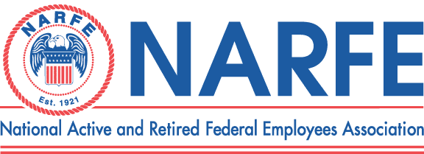

 |  |  |  | Treasurer's Monthly Report
 |  |  | Chapter Number |  | 1192 | Location: | TriCities WA
Period Ending: |  | May 31, | 2011
 | RECEIPTS |  |  | BALANCE ON HAND - |  | Last Report | $7,232.25
1 | NATL Dues Apr 2011 $130 2012 $10 2013 $10 |  |  |  | 219.72
2 | WSFC Service office
3 | WSFC Membership/MAP/Rebates
4 | Newsletter Donations/Awards |  |  |  | 25.00
5 | PR/Ways &Means/Raffle |  |  |  | 16.00
6 | WSFC Per Capita Rebate
7 | Paid Lunches |  |  |  | 333.00
8 | 0
9 | Chapter Dues - W Hoyt Ben Brown LSA |  |  |  | 20.00 | Hoyt - B Brown
10 | 0
 |  | TOTAL RECEIPTS |  |  | $613.72
 |  |  |  | TOTAL TO BE ACOUNTED FOR |  |  | $7,845.97
 | DISBURSEMENTS
1 | WSFC Assessment Per capita
2 | Chapter Liability Insurance
3 | WSFC Membership MAP
4 | Membership Expenses
5 | Printing/Distinquished Members
6 | Sunshine Committee
7 | Presidents Discretionary Fund
8 | Service Center
9 | PR TCVCB/Advertising/Expos |  |  |  | 100.00 | Sen Life Show Booth Fee
10 | Website Domain
11 | Newsletter 6 Issues -Permit |  |  |  | 70.36 | Postage Addl Newsletters
12 | Secretary Supplies
13 | Treasurer Supplies/MISC/Badges |  |  |  | 91.75 | NARFE Mugs
14 | Conventions/Workshops
15 | WSFC State Convention
16 | Comped and Unpaid Lunches |  |  |  | 39.00 | 2 comp 1 unpaid
17 | Lunches Red Lion 25 |  |  |  | 352.82
 |  | TOTAL DISBURSEMENTS |  |  | $653.93
 |  |  |  |  | SUB-TOTAL |  | $7,192.04
 |  |  |  | TOTAL ACCOUNTED FOR |  |  | $7,192.04
OBLIGATIONS
1 | Newsletter Expenses |  |  |  | 421.00
2 | WSFC Dues |  |  |  | 238.00
3 | Multiyear dues 2012 ($492)2013 ($70)2014 ($20) |  |  |  | 582.00
4 | WSFC State Convention |  |  |  | 1,200.00
 |  | TOTAL OBLIGATIONS |  |  | $2,441.00
 |  |  |  | BALANCE ON HAND FOR USE |  |  | $4,751.04
Treasurer Signature____Nancy Crosby________________________________ |  |  |  |  | Date | May 31, 2011

