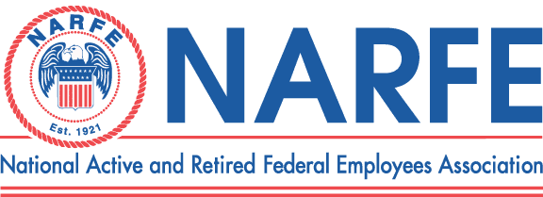

 |  |  |  | Treasurer's Monthly Report
 |  |  | Chapter Number |  | 1192 | Location: | TriCities WA
Period Ending: |  | October 31, | 2011
 | RECEIPTS |  |  | BALANCE ON HAND - |  | Last Report | $6,462.75
1 | National Dues Income Sept 2011 170. 2012 10. 2013 10. DW119.52 |  |  |  | 311.52
2 | WSFC Service office
3 | WSFC Membership/MAP/Rebates
4 | Newsletter Donations/Awards |  |  |  | 69.00
5 | PR/Ways &Means/Raffle |  |  |  | 12.00
6 | WSFC Per Capita Rebate
7 | Paid Lunches |  |  |  | 322.00
8 | 0
9 | 0
10 | 0
 |  | TOTAL RECEIPTS |  |  | $714.52
 |  |  |  | TOTAL TO BE ACOUNTED FOR |  |  | $7,177.27
 | DISBURSEMENTS
1 | WSFC Assessment Per capita
2 | Chapter Liability Insurance
3 | WSFC Membership MAP
4 | Membership Expenses |  |  |  | 70.00 | Rebates Long/Bietz
5 | Printing/Distinquished Members
6 | Sunshine Committee
7 | Presidents Discretionary Fund
8 | Service Center |  |  |  | 105.42 | Mileage @Printing
9 | PR TCVCB/Advertising/Expos
10 | Website Domain |  |  |  | 24.00 | 2011 2012
11 | Newsletter 6 Issues -Permit
12 | Secretary Supplies
13 | Treasurer Supplies/MISC/Badges
14 | Conventions/Workshops
15 | WSFC State Convention
16 | Lunches Red Lion 23 |  |  |  | 321.85
 |  | TOTAL DISBURSEMENTS |  |  | $521.27
 |  |  |  |  | SUB-TOTAL |  | $6,656.00
 |  |  |  | TOTAL ACCOUNTED FOR |  |  | $6,656.00
OBLIGATIONS
1 | Newsletter Expenses |  |  |  | 129.68
2 | WSFC Dues
3 | Multi Year Dues 2012$583 2013 $150 2014$30 2015 $10 |  |  |  | 773.00
4 | WSFC State Convention
 |  | TOTAL OBLIGATIONS |  |  | $902.68
 |  |  |  | BALANCE ON HAND FOR USE |  |  | $5,753.32
Treasurer Signature_________Nancy Crosby__________________________ |  |  |  |  | Date | October 31, 2011

